Experiment 8 N.srivaradeepak
Aim 192572075
To implement the Depth-First Search (DFS) algorithm for traversing a graph using Python.
Algorithm
- Start from the source node.
- Mark the source node as visited.
- Print the current node.
- Visit each unvisited adjacent node recursively.
- Repeat until all reachable nodes are visited.
Program
# Function to perform Depth First Search (DFS)
def dfs(graph, node, visited):
if node not in visited:
print(node, end=" ")
visited.add(node)

# Visit all adjacent nodes
for neighbor in graph[node]:
dfs(graph, neighbor, visited)

# Graph represented as an adjacency list
graph = {
'A': ['B', 'C'],
'B': ['D', 'E'],
'C': ['F'],
'D': [],
'E': ['F'],
'F': []
}

# Set to store visited nodes
visited = set()

print("DFS Traversal:")
dfs(graph, 'A', visited)

Output:

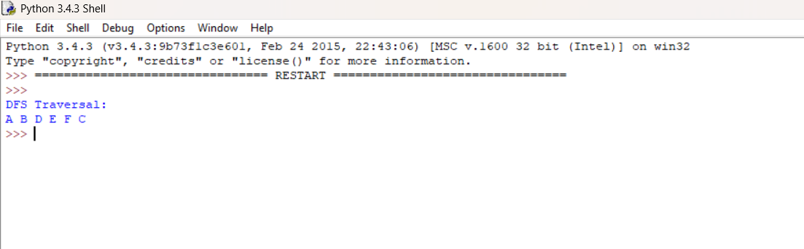

Result
The program successfully implements the Depth First Search (DFS) algorithm. Starting from node A, the traversal order obtained is:
A → B → D → E → F → C

